# Lab Assignment Activities, File permissions in Linux

**Project Description**

The research team wants to organize the files permission based on the security and importance. Check the permission and update that for proper security. Also, change authorization who can access and who can not access.

To update the changing and finish the task i have use the following Linux command:

**Check File and Directory Details**

I have used the Linux exercise shell to see the result of the changes and details of those files.

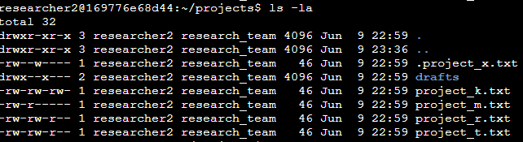

First of all, I have checked the bash, how many files are in the project directory. Press (**ls**) and display all the files in the project. Then is write (**ls -la**), it displays all files and hidden files too. And one hidden file name is (**.project_x.txt**) and other files were normally not hidden.

## 

**Describe the Permissions String**

I have learned from the lesson video that permission strings have 10 characters which are formatted like this - **drwxrwxrwx**. These 10 characters indicate the permission of the files access.

– The d mean directory

– **r** means the “read” the owner has permission for reading the files and documents.

– **w** meaning is writing permission of the owner and user and others.

– and **X** meaning they have permission for execute the files.

Moreover, here has 3 part of the “Read”, “Write” and “Execute”

* The 1st 3 **rwx** permission for the “User”.
* The 2nd **rwx** has permission for “Groups” and
* last 3 **rwx** has permission for “Others”.

This files and directory have lots of important and secret information. So, I have to hide those files and directory based on the importance and permission.

## 

**Change File Permissions**

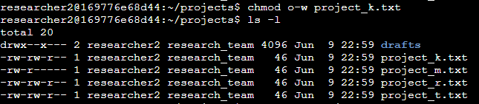

The file project_k.txt has written permission for others. Which is not secure for the file for the other. The requirement was to change the permission and remove the written permission of the (**project_k.txt**).

I have used (**chmod o-w project_k.txt**) commands and changed the permissions for others.

Then I have used (**ls -la**) to check if the files are updated or not.

## 

**Change File Permissions on a Hidden File**

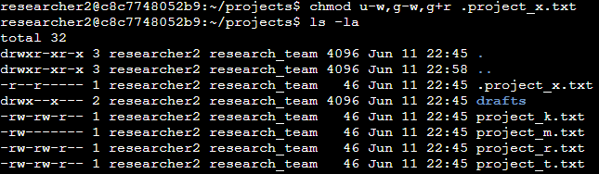

The requirement of the team had to change the hidden files permission changed for more secure. Because the hidden had written permission for user and group. I have use

**Chmod** for changing and the file permission for “user” removes the written (**u-w, g-w**) and reading permission for “group”. And adding “read” (**g+r**) permission for “group”.

I have learned from the lesson that if (**.**) doc signs before the file, it means its hidden file.

Always double check the files about the permission.

## 

**Change Directory Permissions**

The **researcher2** has another file which is drafts. The team wants the drafts directory to have proper security and specific permission to access the file. Need to set up who has permission for which file.

The sample lab activities for this change I have done:

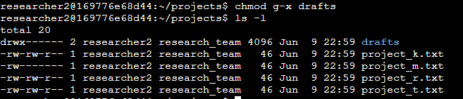

For changing the directory permissions I have used the same command **chmod** for the drafts file which is not completed. The team wants to remove the execute permission for the group user. For displaying all files I have used (l**s -l**). (**ls -la**) command shows all files and hidden files too. Here the drafts file is not hidden. So i have use (l**s -l**)

“Groups” should not have execute permission for **execution (x)**, if they have secure and confidential documents.

## 

**Summary**

The directory was the **projects** directory and there were few files and different permission modes.

In this lab exercise I have changed several times file permission and changed the hidden file permission of the project directory.

At the beginning, I checked (**ls -l**) which directory the bash belonged to.

Then navigate (**cd projects**) the projects directory and check the directory details (**ls -la**).

Based on the requirement, I need to change the file’s and directory permission access for the user, group and others by the **chmod** comment. The most important part is - the changed the file permission of the hidden file. Hidden files should not be permitted to be written or executed for the other.